THE MCPHILLAMYS GOLD DEPOSIT, KINGS PLAINS, NSW. DISCOVERY HISTORY AND GEOLOGY OF THE MCPHILLAMYS GOLD DEPOSIT, LACHLAN FOLD BELT, NSW.

Tara French, Peter Duerden, Jeff Bigelow, Hugh Simmons, Paul Flitcroft.
Regis Resources Ltd, Alkane Resources Ltd, Newmont Exploration Pty Ltd
2015 Mines and Wines Conference, Perth, 3rd - 4th September 2015.

Key Words
Orogenic gold, exploration history, exploration methods, geochemistry, hydrothermal alteration, McPhillamys.

Abstract
McPhillamys is interpreted as an orogenic shear hosted gold deposit located in the eastern subprovince of the Lachlan Fold Belt 30 km west of Bathurst, in Central Western NSW. McPhillamys and the surrounding Blayney-Kings Plains area was worked in the 1850s as an alluvial gold field, with some small scale open pit and underground workings in the district. Minor hard rock mining operations were carried out at McPhillamys hill during this time with little success. In 1980 Australian Occidental Pty Ltd and Windsor Resources Ltd recognised the potential for orogenic gold mineralisation along the regional scale Godolphin-Copperhania thrust fault which runs through the Blayney-Kings Plains district. In 1998 Hargraves Resources NL defined a cohesive >3 ppb gold Regoleach auger-soil anomaly (Ingledoon anomaly) trending at 340° for over 7 km across the McPhillamys hill south-southeast to Hodsons Mine. This anomaly included coincident >10 ppb gold and >80 ppm tellurium over 500 m strike on McPhillamys hill adjacent to old gold workings.
The Ingledoon anomaly was refined in 2005 by Alkane and Newmont as part of the Orange District Exploration Joint Venture with infill auger-soils analysed by aqua regia which defined a 200 m wide >100 ppb gold anomaly across McPhillamys hill with associated arsenic-copper-lead-bismuth over 600 m strike. While the previous Regoleach work successfully defined a broad gold anomaly the 10 times increase in magnitude of anomalism using aqua regia digest highlights the potential pitfalls of Regoleach as an analytical method for exploration using low level gold as a geochemical indicator in regions where gold in soil anomalism can be as low as 3 - 8 ppb.
McPhillamys Gold Deposit is hosted in a shear zone within Silurian dacitic volcaniclastics which vary in composition from crystal tuffs to agglomeratic matrix supported accretions. The cataclastic nature of the volcaniclastics would have resulted in facies changes over short strike distances, any stratigraphic variation in this unit is not a controlling factor for gold mineralisation. The gold mineralisation is structurally controlled by the shear zone within the dacitic volcaniclastics,.
Gold mineralisation is associated with a hydrothermal alteration assemblage of quartz+carbonate (ankerite)+white mica (phengite)+pyrite+/-chalcopyrite+/-pyrrhotite+/-chalcocite+/- biotite. Elevated gold grades over 1 g/t are associated with very coarse euhedral pyrite, white mica, quartz and carbonate
Initial drill testing conducted by Alkane in 2006 identified significant gold mineralisation across a 200 m wide zone over 450 m strike. Subsequent diamond drilling confirmed the continuation of gold mineralisation at depth. Alkane announced the first resource estimate in 2010 using two lower cuts 0.3 g/t and 0.5 g/t gold for 75.15 million tonnes @ 1.13 g/t gold for 2.72 million ounces and 57.35 million tonnes @ 1.36 g/t gold for 2.5 million ounces respectively.
Regis acquired the property in November 2012 and completed infill resource drilling from January to June 2013. 86 holes were drilled for 25,795 m to reduce the drill spacing to 50 m by 50 m across McPhillamys gold deposit. Regis announced an updated resource estimate in 2014 using a lower cut of 0.4g/t gold for 73.2 million tonnes @ 0.94 g/t gold for 2.21 million ounces.

Introduction
The McPhillamys gold project is located in the east Lachlan Fold Belt (LFB), in Central Western New South Wales. The LFB Palaeozoic terrain is well known for hosting porphyry copper gold and orogenic gold mineralisation, however the McPhillamys gold deposit is the most significant gold discovery in the LFB since the early 1990s when Cadia Hill was discovered. The Cadia gold mine, owned and operated by Newcrest includes substantial resources of 44 million ounces of gold and 8.6 million tonnes of copper.
Regis Resources Ltd (Regis) is an ASX listed gold mining and exploration company and currently operates three gold mines at their Duketon Gold Project located in Western Australia. The Duketon Gold Project comprises 10 gold deposits with JORC compliant resources totalling 8 million ounces and reserves of 2.53 million ounces.
Regis acquired the McPhillamys gold project as part of a NSW land package acquisition from joint venture partners Newmont Exploration Pty Ltd (51%) and Alkane Resources Ltd (49%) in November 2012. The project included 3 exploration licences (EL7878, EL5760 and EL6111) over 2 project areas (Figure 1) for a total land holding of 420 km² increasing Regis’ gold resources to 10 million ounces.

Location
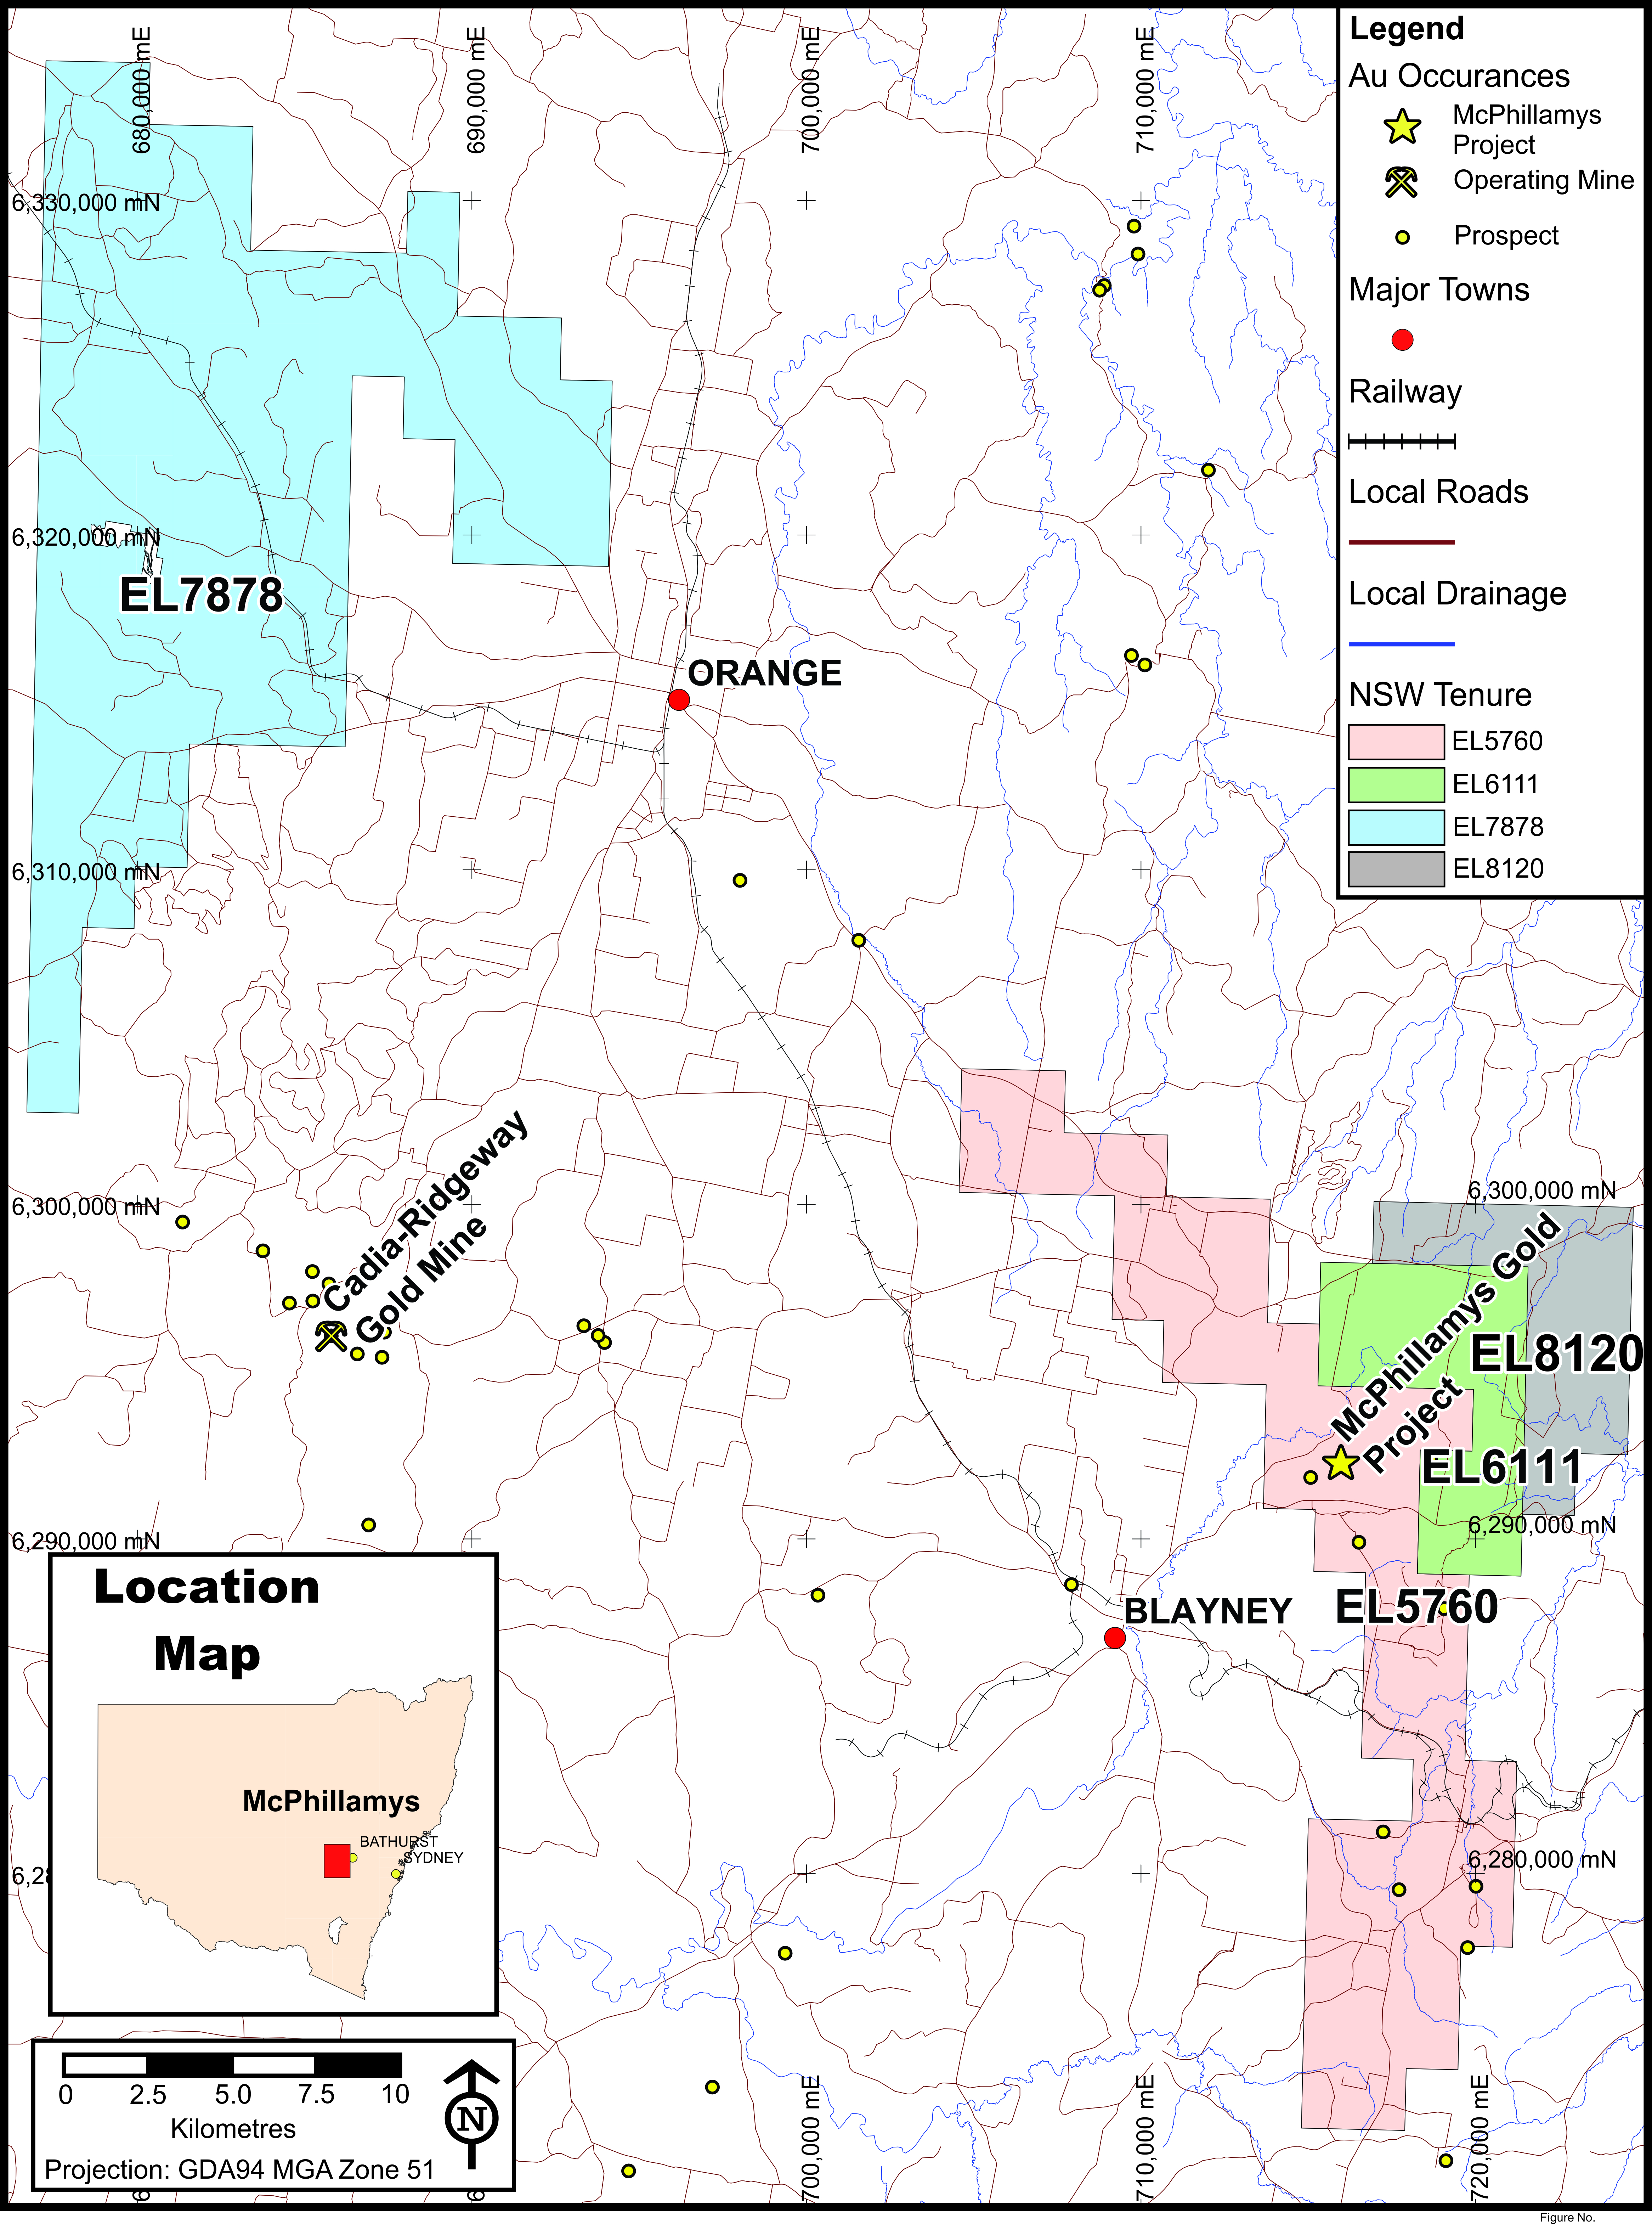
The McPhillamys gold deposit is located 30 km west of Bathurst, and 30 km SE of Orange (Figure 1) in the centre of EL5760 and can be accessed by the Mid Western Highway, or the Mitchell Highway. The project area is 10 km north east of Blayney.
Figure 1 Regis Resources Ltd current tenure holding in NSW

Exploration History
Gold was initially discovered in the district in 1851 with an alluvial find at Fish River near Bathurst, and triggered the first gold rush which continued for approximately 30 years. A number of alluvial gold fields found along tributaries of the Belubula River were worked in the area surrounding the McPhillamys gold deposit in the 1850s and 60s.
Early hard rock mining at McPhillamys hill began in 1888, but was largely unsuccessful. Two shafts were sunk to 30 m and 35 m respectively and cross cuts were driven 34 m east and 29 m west through the mineralised zone which reportedly intersected 21 gold bearing quartz veins (Roche, 1888), however no production or payable finds were reported. Mining at McPhillamys continued sporadically, in line with gold prices, over the next 50 years. The only reported production records are for 1894 where 6.2 oz of gold was extracted from 4 tonnes of ore.
Both gold and copper mining was widespread in the Blayney-Kings Plains district in the late 1800s to early 1900s.

McPhillamys Discovery
During the 1960s and 1970s exploration across the Blayney-Kings Plains district focused on VMS base metals or copper-gold mineralisation associated with late Ordovician intrusives located on the western side of the Godolphin-Copperhania thrust fault zone (GCFZ).
The earliest recorded exploration using modern techniques was carried out in 1970 by Resource Exploration NL which completed aeromagnetic surveys, geological mapping, stream sediment sampling and ground radiometric surveys across the McPhillamys prospect and Kings Plains district in the search for base metal mineralisation. Stream sediment samples (-80 µm) around the McPhillamys hill returned values of 40-80 ppb Pb, >150 ppm Cu and >110 ppm Ni, the area was considered unprospective and base metal exploration in the area diminished around 1975. A resurgence of exploration followed a rapid rise in the gold price in the late 1970s which peaked at US$850 per ounce in January 1980. Interest in the Blayney-Kings Plains area was once again ignited, as documented by Tinaron Pty Ltd in 1981, which reviewed historical records in the search for economic gold mineralisation. McPhillamys hill was noted as having potential for gold mineralisation however access to the property was not possible due to land access issues.
Teck Exploration completed a DIGHEM II geophysical survey in the early 1980s over the northern portion of the project exploring for base metals, several anomalies were defined, but dismissed as having base metal potential after field assessment. Australian Occidental Pty Ltd followed up on the gold targets in the mid-late 1980s as defined by Tinaron Pty Ltd and drilled at the Last Chance Gold Mine and Confidence Gold Mine. A joint venture was established with Windsor Resources NL, which completed soil / soil auger sampling, rock chip sampling, RC drilling and ground magnetic surveys. This work was focused around the Last Chance gold mine and along strike to the south. A number of rock chip samples were collected from the McPhillamys hill, however no anomalous results were reported. Windsor Resources surrendered the ground in 1990.
Newcrest recognised the potential for structurally controlled gold mineralisation constrained by NE/SW faults cross cutting the GCFZ, and were interested in the Silurian –Devonian volcaniclastics and sediments on the eastern margin of the GCFZ. However no field exploration was completed during their period of tenure from 1991 to 1994.
In 1994 Hargraves obtained the licence which encompassed the strike length of the GCFZ, extending 30 km north and south of the McPhillamys prospect. Hargraves focused on the potential for porphyry copper mineralisation at the southern portion of the lease and structurally controlled gold mineralisation around historical workings on areas across the GCFZ at Last Chance, across Kings Plains, to the south and west of Bright star, and on the eastern side of the GCFZ at Moorilda South. Unfortunately at this time the McPhillamys prospect was still inaccessible due to landowner opposition.
In 1997 Hargraves identified the need for a comprehensive surface geochemical map covering the strike extent of the GCFZ and other prospective areas. Regional scale stream sediment sampling was carried out across the majority of the licence, 99 x 5 kg samples were collected for Bulk Leach Extractable Gold (BLEG) analysis. Samples were analysed for Au, and a second 2 kg sample was collected and analysed for Cu, Pb, and As. Anomalous Au results in drainage were then followed up with a wide spaced soil sampling program.
Initially 148 B horizon samples were collected by hand auger at 50 m intervals over 500 m spaced traverses, the samples were composited over 250 m and the sample location recorded at the central sample site. This would have distorted any anomalous soil results by producing lower level, broader anomalies. Any soil anomalies >10 ppb Au were infilled at 50 m intervals on 250 m spaced traverses. Hargraves recognised problems with this exploration method when gold mineralised trends could not be correlated between traverses. In an attempt to resolve this issue a second phase of infill sampling was carried out on 20 m intervals along E-W lines north and south of previously define Au anomalies. The results of this sampling program did not resolve the problem and produced discrete anomalies <30 m wide and <150 m along strike.
In 1998 access was gained to the McPhillamys prospect on the Ingledoon property and Hargraves further expanded the area covered by soil-auger sampling. 3,185 samples were collected at 50 m intervals on 500 m spaced traverses. Again two samples were composited to produce 1 sample per 100 m, therefore 1,723 samples were submitted to the laboratory. A >3ppb gold Regoleach auger-soil anomaly referred to as the “Ingledoon” anomaly was defined over 7 km trending 340° across the McPhillmays hill, south-southeast to Hodsons Mine (Figure 2). Eight priority gold targets were defined within this trend. The highest ranked target being the McPhillamys hill with >10 ppb gold and >40 ppm tellurium (Figure 2) over 400 m wide E-W and 1 km N-S along strike, and adjacent to old gold workings. The Regoleach gold anomaly at McPhillamys was coincident with tellurium only, no other elements showed good correlation with gold.
Hargraves recommended following up on this anomaly with infill auger soil sampling, ground magnetometry and RC drilling. Following a company take over in 1999, the company did not pursue the mineral potential and the ground was relinquished. The often volatile nature of the exploration industry highlights the discovery “near miss”, where good drill ready targets, generated though methodical and thorough exploration, are dismissed and discovery opportunities overlooked.
LFB Resources (a wholly owned subsidiary of Alkane Resources Ltd) acquired tenure covering the GCFZ in May 2000. Exploration was focused on shallow structurally controlled gold mineralisation. A detailed aeromagnetic survey was completed across the entire lease in 2004 to provide additional information to assist in interpreting the structural controls of historically worked gold mineralisation associated with the GCFZ. In August 2005 Newmont Australia Ltd entered into a JV with LFB Resources to earn 51% within 5 years through expenditure of $5 million and an addition 24% to fund the project through to completion of a bankable feasibility study. LFB Resources continued to manage the project until 2008 when Newmont took over the active project management role.
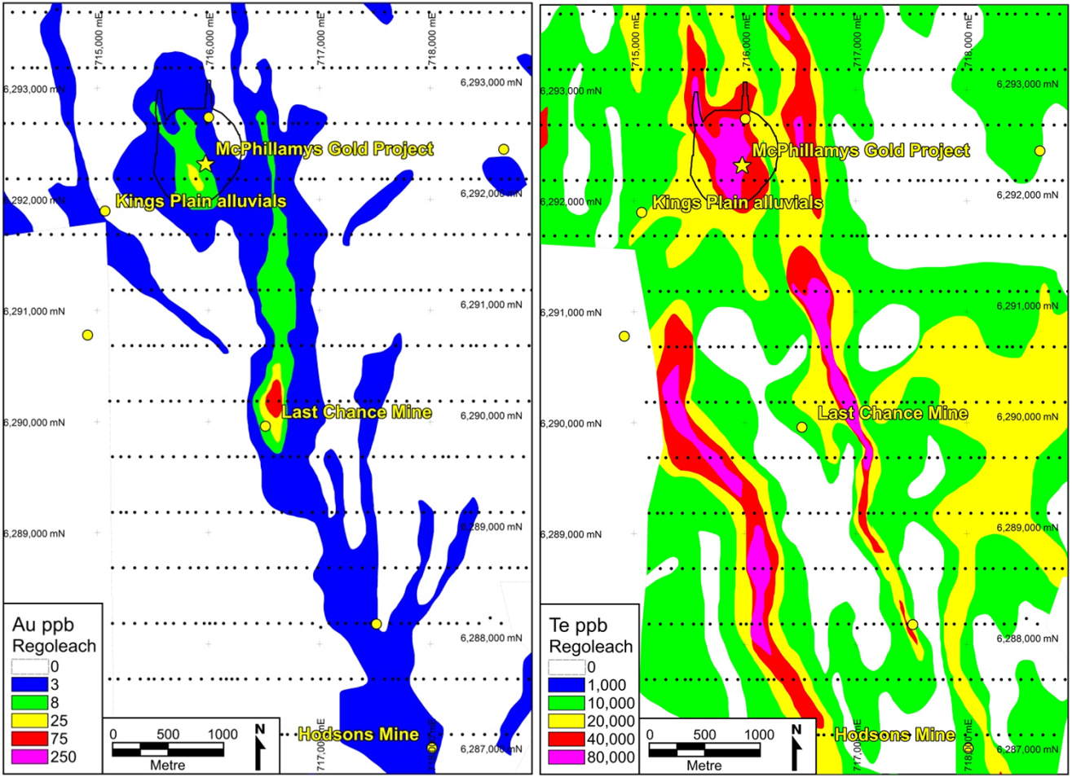
The Hargraves Regoleach anomaly at McPhillamys was followed up with geological mapping and rock chip sampling. A 500 m x 200 m zone of argillic alteration was identified associated with disseminated iron oxide boxwork after sulphide and quartz veins in outcrop, and a strong radiometric K high and magnetic low. Results of rock chip samples taken from the McPhillamys gold mine returned less than encouraging values with the highest assay 1.03 g/t gold. However, in 2006 an infill program of soil-auger sampling at 50 m spacings along 100 m traverses was completed, including 385 samples across McPhillamys. Two samples were collected from each site by mechanised auger to an average depth of 1.2 m, one sample was analysed by Ultratrace in Perth using Aqua Regia digest ICP-MS finish for Au and ME-ICP41s for Cu, Zn, Ag, As, Mo, Bi and Mn, the second sample was analysed for Au only by BLEG A direct cyanide leach. The Aqua Regia analysis confirmed a coherent gold anomaly at the McPhillamys hill >100 ppb across 650 m x 200 m with coincident As-Mo-Pb-Bi-Cu (Figure 3), and a second linear anomaly 800 m east of McPhillamys hill. The results for the BLEG A analysis were not reported.
Figure 2 Contoured Hargraves 1998 Regoleach Gold and Tellurium auger soil geochemistry showing 340° trend, and significant anomalism at McPhillamys.
The results of the aqua regia analytical method clearly define anomalous zones of mineralisation which are continuous between traverses and have been contoured to identify mineralised trends and interpret geological structures (Carver, 2013). The coincident multi-element aqua regia anomalies also illustrate the ineffectiveness of Regoleach to identify low level anomalies for gold and other indicator elements including As, Bi, Cu and Mo.
In 2006 Alkane initially tested the >100 ppb gold soil anomaly with 25 shallow aircore holes (KP006-030) for 1,040 m across three traverses. These were the first drill holes completed over the McPhillamys gold deposit. The drilling did not reach fresh rock and only tested gold mineralisation in the oxide zone.
Diamond and RC drilling was then used to test for gold mineralisation in the fresh rock zone. Diamond hole KPD001 was the first hole to demonstrate wide zones of low grade gold mineralisation occur at McPhillamys. RC holes KP047 and KP048 (Figure 4) confirmed this gold mineralisation continued over 180 m along strike from KPD001 and highlighted the potential for a large low grade gold mineralised zone at McPhillamys. In late 2007 KPD003 was drilled 230 m north along strike of KPD001. KPD003 intersected 336 m @ 1.85 g/t Au from 134 m (including 109 m @ 4.07 g/t Au from 348 m) and confirmed McPhillamys as a significant gold discovery.
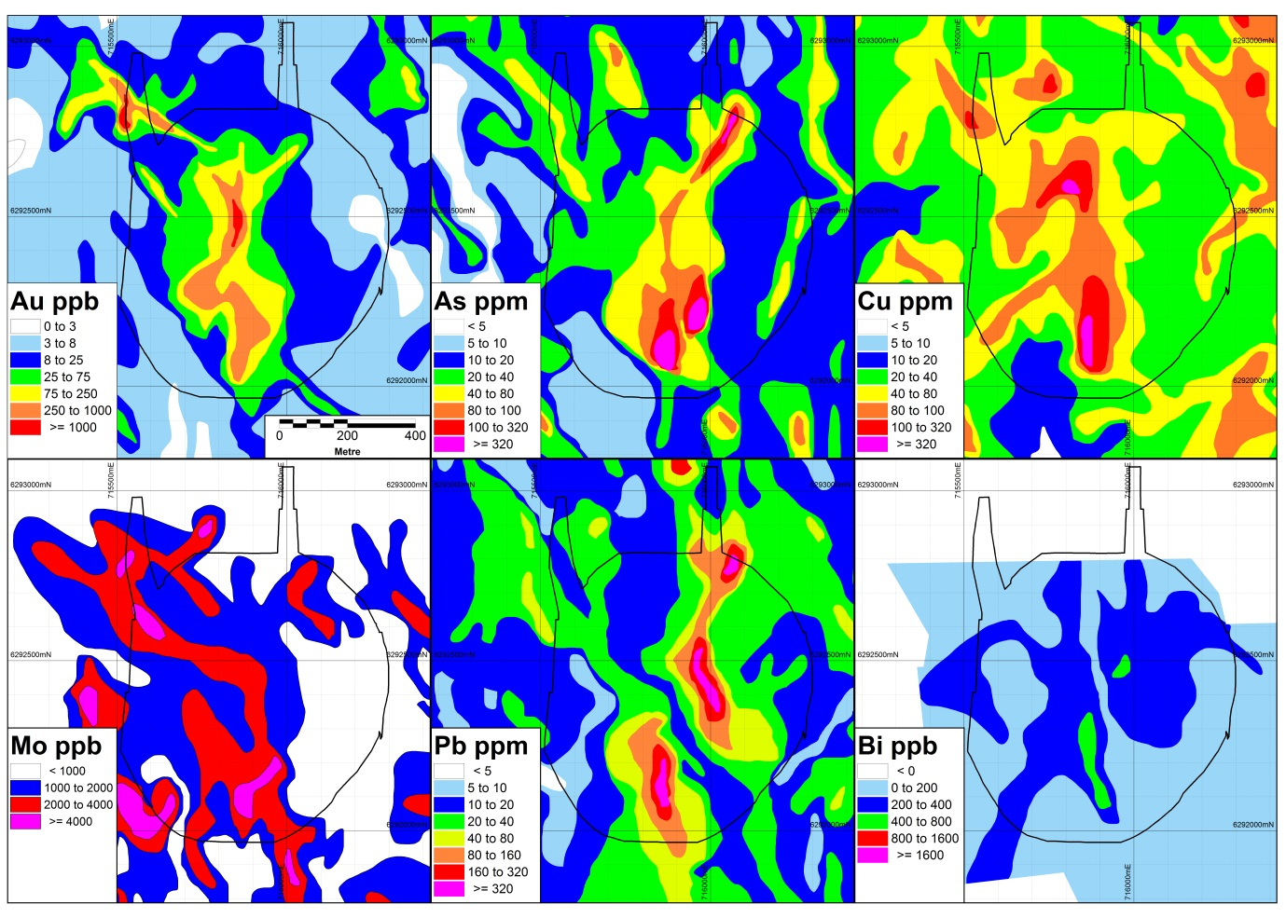
A pole-dipole IP survey was completed on 100 m traverses totalling 17 line kilometres and produced a chargeable anomaly (+55 mv/v) across McPhillamys which is coincident with the mineralised shear zone.
Figure 3 Aqua Regia soil-auger contours Gold, Arsenic, Copper, Molybdenum, Lead, Bismuth.
Further drill testing was carried out to define the McPhillamys gold deposit. Newmont completed 10 diamond drill holes and 1 RC hole during 2009 and 2010. A total of 67 holes were drilled across the resource on a 50 m x 100 m - 150 m grid and included aircore, reverse circulation and diamond core. The mineralised zone was found to continue over 800 m strike. This drilling information was included in the first resource estimate announced by Alkane in July 2010 using two lower cuts of 0.3 g/t Au and a 0.5 g/t Au. The resource was estimated at 75.15 million tonnes at 1.13 g/t Au for 2.72 million ounces using a 0.3 g/t Au cut off. Using a 0.5 g/t cut off the resource was estimated at 57.35 million tonnes at 1.36 g/t Au for 2.5 million ounces.
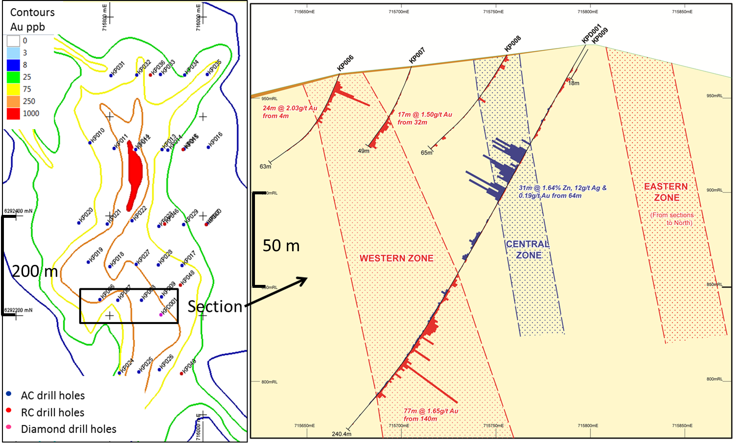

Figure 4 Aqua Regia gold in soil anomaly on left with initial drilling program. Results of first diamond drill hole on right 6292230mN.

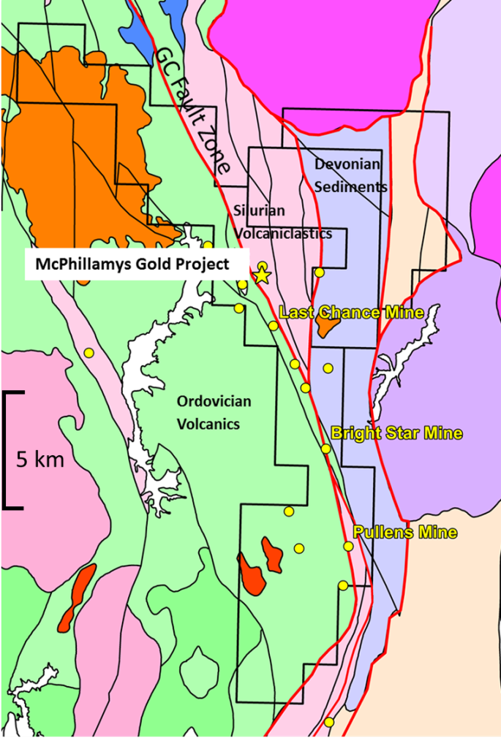
Between January and June 2013 Regis completed a program of infill resource drilling to reduce the drill spacing across the mineralised zone to 50 m x 50 m in order to upgrade inferred resources to indicated. Drilling commenced at the end of January 2013, 86 holes were drilled for 25,975 m. Drilling methods included standard 5.5” reverse circulation, PQ, HQ and NQ diamond drilling.

Figure 5 Local Geology with significant gold occurrences.
The McPhillamys discovery is a testament to persistent and effective exploration. Aqua regia soil geochemistry used in conjunction with IP data are effective methods of exploration for orogenic gold deposits associated with disseminated sulphides in this terrain. These techniques can effectively be used to define drill ready targets across the district where there is good exposure and / or a shallow regolith profile, and no impervious Tertiary basalt cover.

Geological Setting and Stratigraphy
The McPhillamys Gold Project is located in the eastern sub-province of the Lachlan Fold Belt (LFB), New South Wales, Australia. The LFB is a highly endowed Palaeozoic mineral province due to a complex tectonic history (Fergusson, 2003; Foster and Gray, 2000; Glen et al. 2002, Gray, 1997; Gray & Foster, 1997) and is host to over 150 million ounces of gold.
The McPhillamys gold deposit occurs on the eastern side of the Sherlock Fault, part of the GCFZ (Figure 5) in the eastern sub-province of the LFB. The deposit lies along one of a series of N-S trending splays/horsetail structures that occur at the inflection of the GCFZ where the orientation changes from NNW-SSE to SSW-NNE. The splays are defined by strong shearing and faulting and continue to the south for over 6km. These structures host numerous smaller gold deposits (Figure 5) including Last Chance, Confidence, Mount Willis, Bright Star.
The McPhillamys gold deposit occurs on the eastern side of the Sherlock Fault, part of the GCFZ (Figure 5) in the eastern sub-province of the LFB. The deposit lies along one of a series of N-S trending splays / horsetail structures that occur at the inflection of the GCFZ where the orientation changes from NNW-SSE to SSW-NNE. The splays are defined by strong shearing and faulting and continue to the south for over 6 km. These structures host numerous smaller gold deposits (Figure 5) including Last Chance, Confidence, Mount Willis, Bright Star.
McPhillamys mineralised shear zone is hosted in Silurian dacitic volcaniclastics which vary in composition from crystal tuffs to agglomeratic matrix supported accretions. The cataclastic nature of the volcaniclastics would have resulted in facies changes over short strike distances, thus precluding any correlation of stratigraphy on section or along strike within this unit. The gold mineralisation is structurally controlled by the shear zone within the dacitic volcaniclastics, any stratigraphic variation in this unit is not a controlling factor for gold mineralisation. The gold mineralisation is well constrained on the western footwall by the Sherlock fault and less well defined on the hangingwall where the shear zone appears to break up along a parallel N-S trending structure. The mineralised shear zone is over 200 m wide and sub-parallel to stratigraphy, dipping steeply at 75-80° to the east.
The volcaniclastics have undergone Greenschist facies metamorphism which has produced a mineral assemblage of biotite/chlorite, muscovite, quartz, k feldspar, which has been overprinted at McPhillamys by a hydrothermal alteration assemblage of quartz+white mica (phengite)+carbonate (ankerite) along with gold and sulphide mineralisation.

Gold Mineralisation
McPhillamys gold mineralisation is located within a shear zone that has been defined over a width of 200 m, 800 m along strike and 700 m down dip. The gold mineralised zone trends in a northerly direction and dips steeply 75° to 85° to the east or sub-vertically and plunges moderately 50° to the north-northeast (Figure 6 & 7). The mineralisation is bound to the west by the Sherlock Fault and is somewhat structurally constrained between a set of normal faults trending northeast, southwest produced by dextral movement along the Sherlock Fault. These cross cutting faults were likely synchronous with the timing of gold mineralisation and have disrupted the cohesive 200 m wide main lode, disseminating gold mineralisation into a series of elongate lenses (Figure 6).
The main lode consists of broad intercepts 200 m wide with gold grades in the order of 1-2 g/t in the fresh rock zone which continue to surface where the width of mineralisation is reduced to 50-100 m in the oxide zone (Figure 6). The moderate northerly plunge direction is reflected in elevated grades in the oxide zone across the southern portion of the deposit (Figure 6 & 7).
The base of weathering/oxide mineralisation occurs at 20 m to 50 m below surface. The saprock interface or transitional zone extends from 50 m to 100 m down slope or where brittle fault structures have allowed for deeper weathering. Over 85 % of gold mineralisation occurs in the hypogene zone at McPhillamys. There is a lack of supergene alteration in the upper weathering profile, and mineralisation is found to be somewhat depleted in the oxide zone with the exception of where the high grade ore shoot comes to surface.
Gold mineralisation is associated with a hydrothermal alteration assemblage of quartz+carbonate (ankerite)+white mica (phengite)+pyrite+/-chalcopyrite+/-pyrrhotite+/-chalcocite+/- biotite. Elevated gold grades over 1 g/t are associated with very coarse euhedral pyrite, white mica, quartz and carbonate. Petrographic analysis suggests that some gold is associated with an earlier phase of potassic (k-feldspar) alteration that has been overprinted by the argillic alteration event (Coote, 2007). The association with potassic alteration is not frequently observed in drill core, however it is reflected in radiometric data and could be used in conjunction with surface geochemistry to prioritise exploration targets.

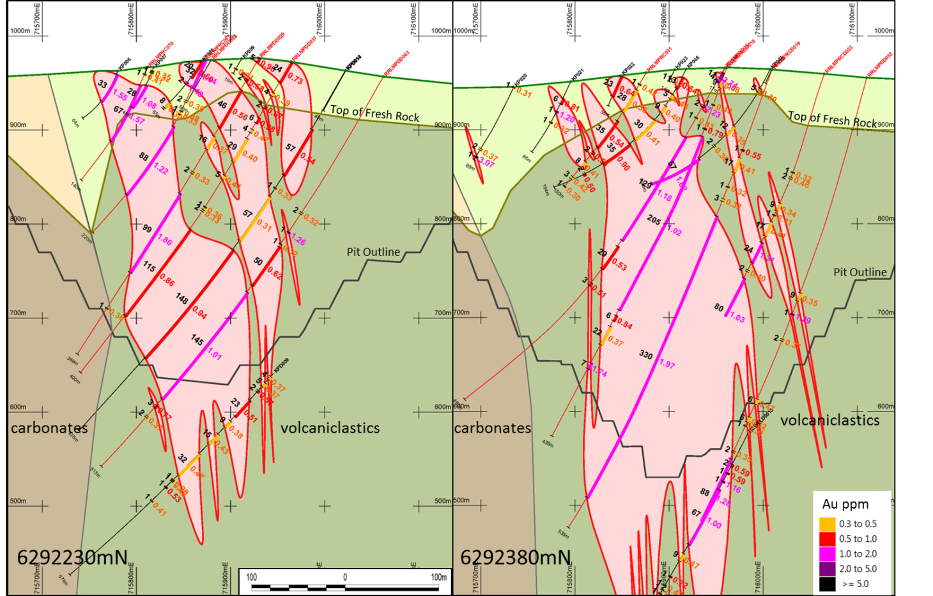
Rb >80ppm
Rb <80ppm
Rb >80ppm
Rb <80ppm

Figure 6 Cross Sections across the McPhillamys deposit. The high grade plunging shoot comes to surface on the discovery line, at 6292230mN. 6292380mN shows lower grades within the oxidised profile. Gold intercepts displayed with metres on left and gold grades on right of drill trace.
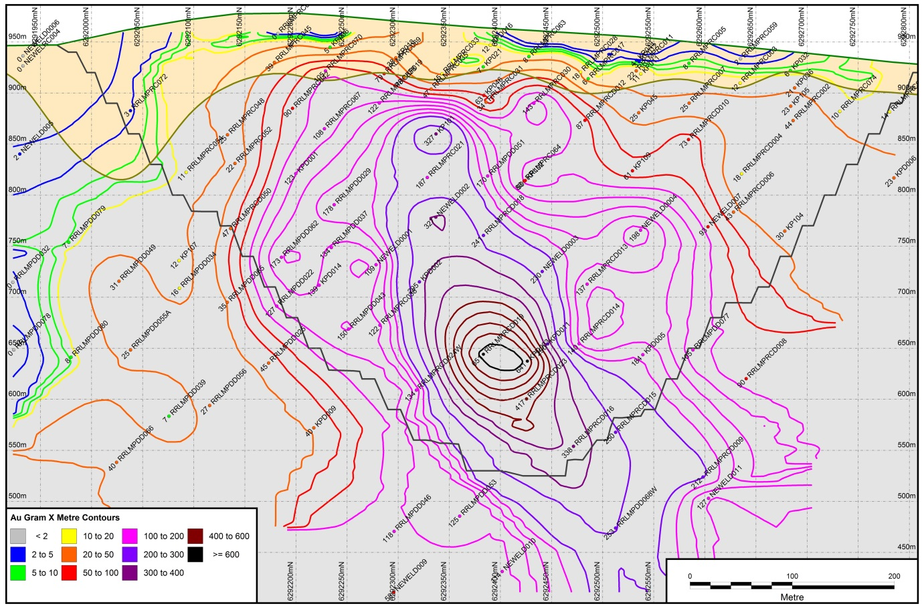

Figure 7 McPhillamys long section - gold gram x metre contours illustrating 50 degree plunge of the main ore shoot, and a decrease in grade within the oxidised profile.

Geochemistry
Hypogene gold mineralisation is associated with white mica+quartz+carbonate+chlorite+pyrite+/-pyrrhotite+/-chalcopyrite. A multi-element analysis including As, Cu, Pb, S and Zn was completed on 68 drill holes across the project area. Sub-economic zinc and lead mineralisation occurs in the hanging wall to the main gold lode, where there is an antithetic relationship between these base metals and the main gold lode. Only rarely are zinc and lead associated with stringy low grade gold mineralisation. The base metal mineralisation is also associated with elevated As and Ag and was previously interpreted to represent epigenetic VMS mineralisation in the hangingwall to the main orebody.
Copper is associated with the deeper gold mineralisation occurring as chalcopyrite with average assay values of 0.2% Cu within the mineralised zone. Arsenic is structurally controlled, and it correlates poorly with Au, but is elevated in the hangingwall and footwall zones to the main lode occurring as discrete high grade intervals associated with faults.
Newmont completed an internal LA-ICPMS analysis that indicates at least three generations of pyrite exist, and the earliest generation was interpreted to be associated with gold mineralising fluids. Gold is generally not associated with sphalerite, galena or argentite. This indicates multiple mineralising events with the earlier base metal mineralisation occurring during sea floor volcanism associated with back arc development. Thrust faults and associated shearing produced during tectonism would have provided a pathway for gold bearing mineralised fluids possibly associated with magmatic activity during the Carboniferous. Gold mineralisation is confined to a shear zone within reworked Silurian dacitic volcanics and is associated with a hydrothermal mineral assemblage of white mica (phengite)+quartz+carbonate (ankerite)+chlorite+pyrite+/-pyrrhotite+/-chalcopyrite.
An extensive XRF study was completed on 53 drill holes across the deposit. Geochemical associations identified from the XRF study are summarised below:
Western Footwall | Main Gold Ore Zone | Eastern Gold Ore Zone | Eastern Hangingwall
Ca, Ce, Cr, Mo, (Rb), (Y), Zr | As, (Ba), Bi, Cu, K, Rb, S, Te | As, (Ba), Bi, Cu, K, (Mn), Rb, S, Te, Ti, Zr | As, Ag, Ca, Ce, Hg, Mn, Pb, Rb, Sb, (Sr), Ti, Zn, Zr

Table 1 Geochemical associations across McPhillamys Gold Deposit.
Std font = anomalous assay results, Bold elements = anomalous in both assays and XRF, (elements in brackets) = anomalous in XRF only.

A key finding of the XRF study is the variation in Rb in the main gold mineralized zone. This is interpreted to define a lithological boundary with Rb < 80 ppm to the west and Rb >80 ppm to the east (Figure 6).
Diamond drill core was re-examined in an attempt to visually identify the different lithological units, based on the new XRF data. The intense shearing and overprinting hydrothermal alteration assemblage (white mica and carbonate) associated with the gold mineralisation event has completely destroyed all primary textures and altered primary mineralogy, therefore no lithological variation could be identified with confidence. However within the mineralised zone higher gold grades >1ppm, and most bonanza gold assays were found to be associated with coarse clast rich lithologies (Simmons and Flitcroft, 2014). This relates to fluid permeability rather than a form of lithological control.
While the geochemical study has provided important information on the geology and geochemistry of the deposit there is no visual means of identifying different lithologies in the field where such hydrothermal alteration persists.

Gold Resource
Alkane quoted the first JORC compliant resource estimate in July 2010 using two lower cuts of 0.3 g/t Au and 0.5 g/t Au. The resource was estimated at 75.15 million tonnes at 1.13 g/t Au for 2.72 million ounces of gold using a 0.3 g/t Au cut off. Using a 0.5 g/t cut off the resource was estimated at 57.35 million tonnes at 1.36 g/t Au for 2.5 million ounces. The resource estimate was based on drilling completed at 50 m spacings on 50 m to 150 m traverses, for a total of 67 drill holes, including aircore, reverse circulation and diamond core.
Regis drilled 86 holes for 25,795 m in 2013 to reduce the drill spacing to 50m by 50m across McPhillamys gold deposit. An updated resource estimate was announced in 2014 using a lower cut of 0.4g/t gold for 73.2 million tonnes @ 0.94 g/t gold for 2.21 million ounces.

Conclusions
The McPhillamys discovery is a testament to persistent and effective exploration. The Regoleach analytical technique used by Hargraves in 1998 produced a low order gold in soil anomaly >10 ppb Au across 1 km strike at McPhillamys. Follow up work by Alkane in 2006 using an Aqua Regia digest re-defined the gold in soil anomaly at >100 ppb Au over 600 m strike. Initial drill testing conducted by Alkane in 2006 identified significant shallow oxide gold mineralisation across a 200 m wide zone over 450 m strike.
Gold mineralisation at McPhillamys is structurally controlled, hosted within reworked Silurian dacitic volcanics, and is associated with a strong hydrothermal mineral assemblage of white mica (phengite)+ quartz+ carbonate (ankerite)+ chlorite +pyrite +/-pyrrhotite +/-chalcopyrite.
Aqua regia soil geochemistry used in conjunction with IP data and good geological field mapping of alteration assemblages are effective methods of exploration for orogenic gold deposits associated with disseminated sulphides in this terrain. These techniques can effectively be used to define drill ready targets across the district where there is good exposure and / or a shallow regolith profile, and no impervious Tertiary basalt cover.

Acknowledgements
The authors wish to thank the board of Regis Resources Ltd for approving this paper for publication in the AIG 2015 Mines and Wines conference papers, and the AIG for the opportunity to present this paper. Past explorers including Alkane and Newmont, Geochemist Richard Carver and Regis staff members have contributed significantly to the understanding of mineralisation at the McPhillamys gold deposit.

References
Carver, R. 2013. McPhillamys Geochemistry Notes for Regis Resources Ltd.
Carver, R. 2014. McPhillamys Drilling XRF Geochemistry for Regis Resourcs Ltd.
Coote, A. 2007. Petrological Studies of Diamond Core and Drill Chips from the McPhillamys Gold Project, NSW, Australia, for Newmont Australia Ltd.
Fergusson, C.L. 2003. Ordovician-Silurian accretion tectonics of the Lachlan Fold Belt, south-eastern Australia. Australian Journal of Earth Sciences, 50, 475-490.
Foster, D. A. & Gray, D. R. 2000. Evolution and Structure of the Lachlan Fold Belt (Orogen) of Eastern Australia. Annual Review of Earth Planetary Sciences, 28, 47-80.
Glen, R.A., Korsch, R.J.,Direen, N.G., Jones, L.E.A., Johnstone, D.W., Lawrie, C.K., Finlayson D.M. & Shaw, R.D. 2002. Crustal structure of the Ordovician Macquarie Arc, Eastern Lachlan Orogen, based on seismic reflection profiling. Australian Journal of Earth Sciences, 49, 323-348
Gray, D. R. & Foster, D. A., 1997. Orogenic concepts - application and definition: Lachlan Fold Belt, eastern Australia. American Journal of Science, 297, 859-891.
Gray D. R. 1997. Tectonics of the south eastern Australian Lachlan, Fold Belt. Structural and Thermal Aspects. In: Burg J. P. & Ford, M. eds. Orogeny through Time, 149–177. Geological Society of London Special Publication 121.
Roche W. Mining Registrars Report: 1888 Bathurst District – Blayney Division in Osborne I. 1975. Annual report compilation Blayney Division – Bathurst Sheet 1878-1972. Geological Survey of NSW, 52pp, ARC006.R00051295.pdf
Simmons H and Flitcroft P. 2014. McPhillamys Draft Technical Report for Regis Resources Ltd.

